SQL Database Scope and Documentation

Overview
This document is to give a detailed summary of the potential project for a database for Vocxi Health. This database would contain all aspects of data collected and distributed throughout the company.

1. Objectives
What is this supposed to achieve?
The goal of this project is to develop a centralized SQL database to store and manage all data processed by the organization. The database will serve as the foundation for data access, reporting, analytics, and future automation initiatives.

2. In-Scope
What features, tasks, and deliverables are included?
- Designing a normalized SQL schema to support current and future data needs.
- Creating tables, relationships, and indexes.
- Data import/export pipelines (e.g., via Excel, CSV, API).
- Establishing role-based access controls.
- Creating a basic GUI interface for non-technical users.
- Hosting the database on a dedicated server. We will use the Vocxi server with Microsoft SQL Management Software
- Documentation for architecture, data flow, and user instructions.
- Basic data validation rules and constraints.

3. Out of Scope
What is not being handled internally or will be deferred?
- Ongoing database maintenance and support. Can be handled internally.
- Data security architecture (may be outsourced to a third-party expert).
- Backend setup (e.g., server provisioning, firewall configuration) – potential to hire a contractor for this phase.

4. Requirements
Functional Requirements:
- Ability to insert, update, delete, and query data.
- Support for relational integrity (foreign key constraints, cascading updates/deletes).
- Role-based access (admin vs. read-only users).
- Audit logs for changes to critical data.
Non-Functional Requirements:
- Performance: Capable of handling up to X transactions per minute.
- Scalability: Easy to extend schema with new tables and relationships.
- Availability: 99.5% uptime for users during business hours.
- Backup & Recovery: Routine backups and recovery tested monthly.
- Usability: GUI interface must be intuitive for non-technical users.

5. Validation
- Constraints in SQL
Constraints in SQL Server are rules that limit the data that goes into our tables. These constraints ensure the validity of the data and help maintain the integrity of the database. Constraints can be defined when tables are created or afterward and can apply to individual or multiple columns.
If we insert data in the column that meets the constraint rule criteria, SQL Server inserts data successfully. However, if data violates the constraint, the insert statement is aborted with an error message.

6. Security
How will we keep the database secure?
Limit permissions for certain people
(ex.
Raia: ability to add/edit folders/content in benchtop testing
Randy: ability to edit content in purchase orders, documentation, technical reports, etc
Greg S: Ability to edit/add content in Manufacturing for functionalizing
)
Main administrator would be notified every time a change is made, and a weekly report will be created off all changes the database.

Configure a firewall (investigate)
Column Level Protection
Row Level Protection
Data Lineage and data integrity
SQL Server security best practices - SQL Server | Microsoft Learn

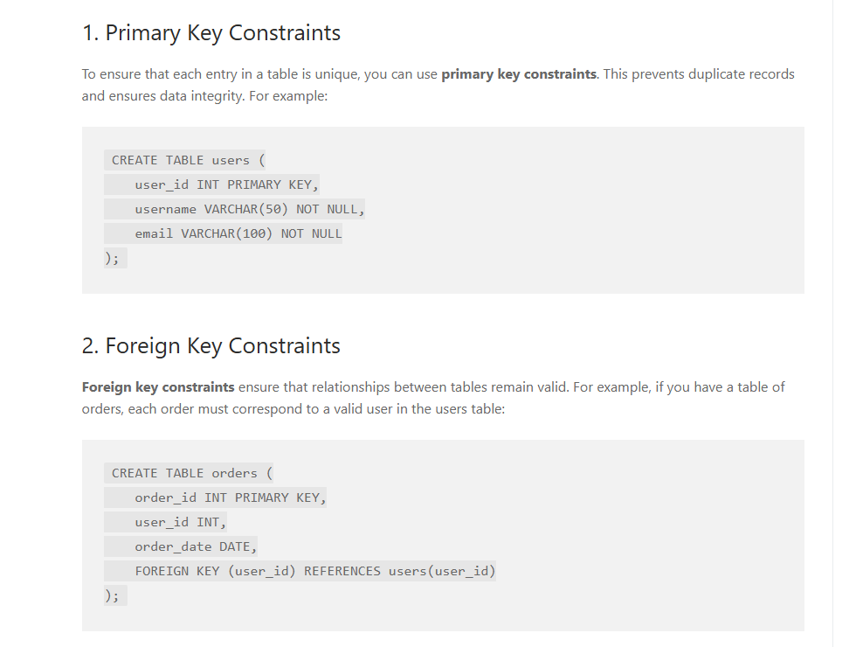

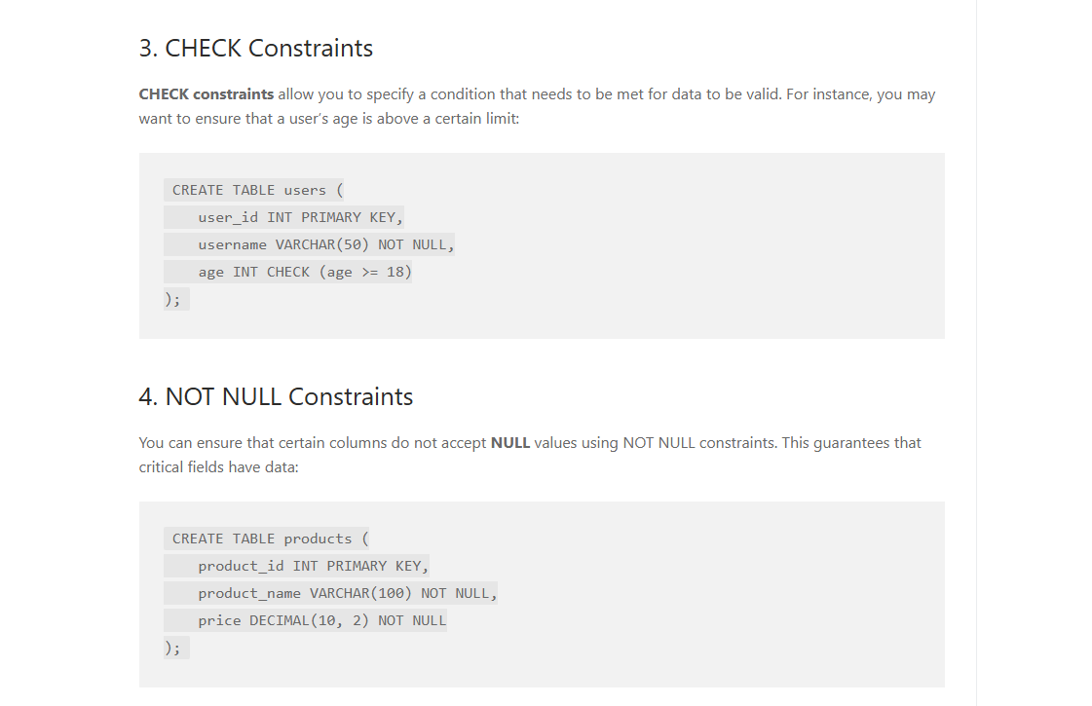
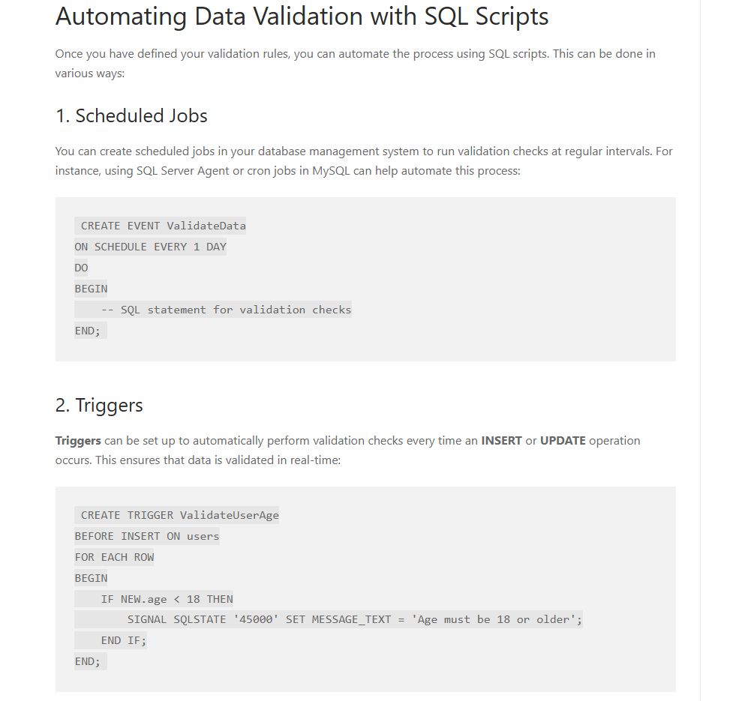
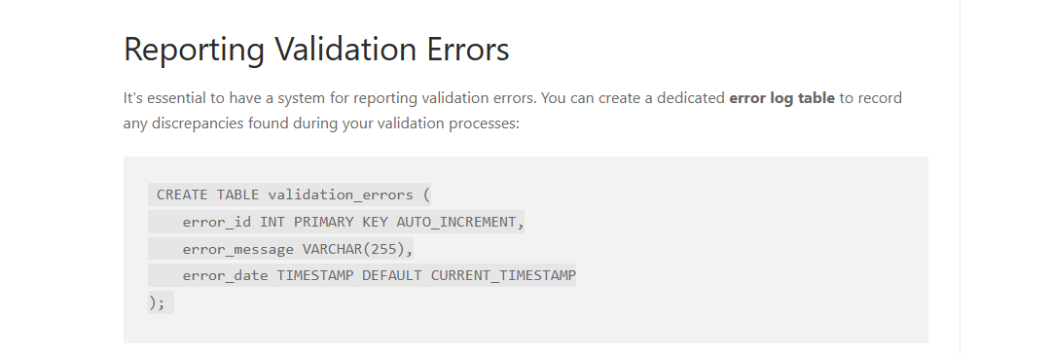
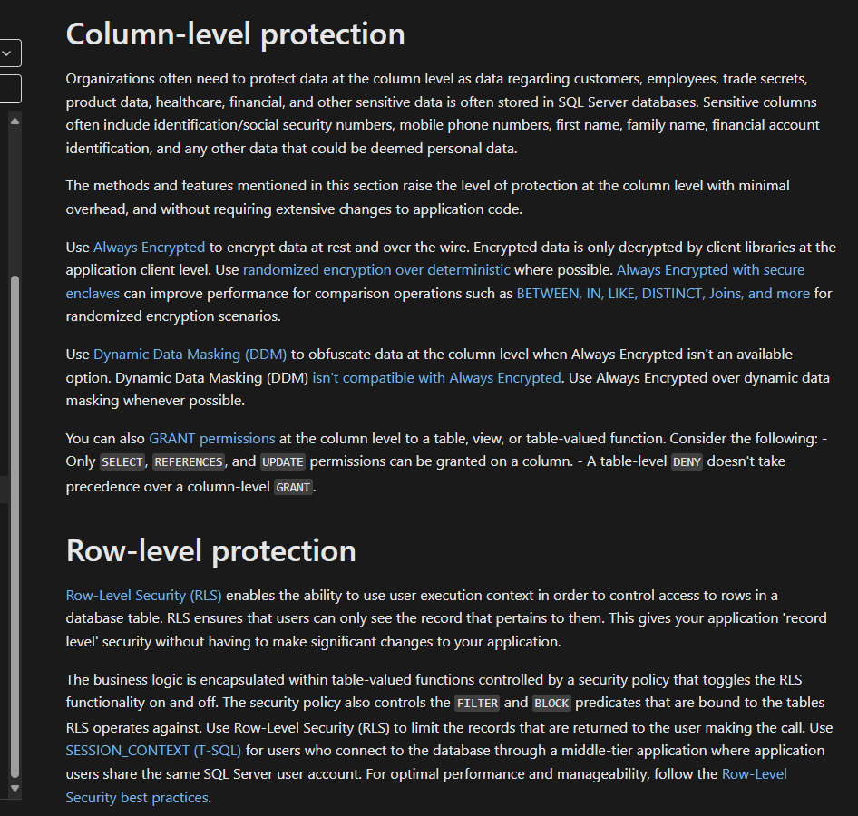
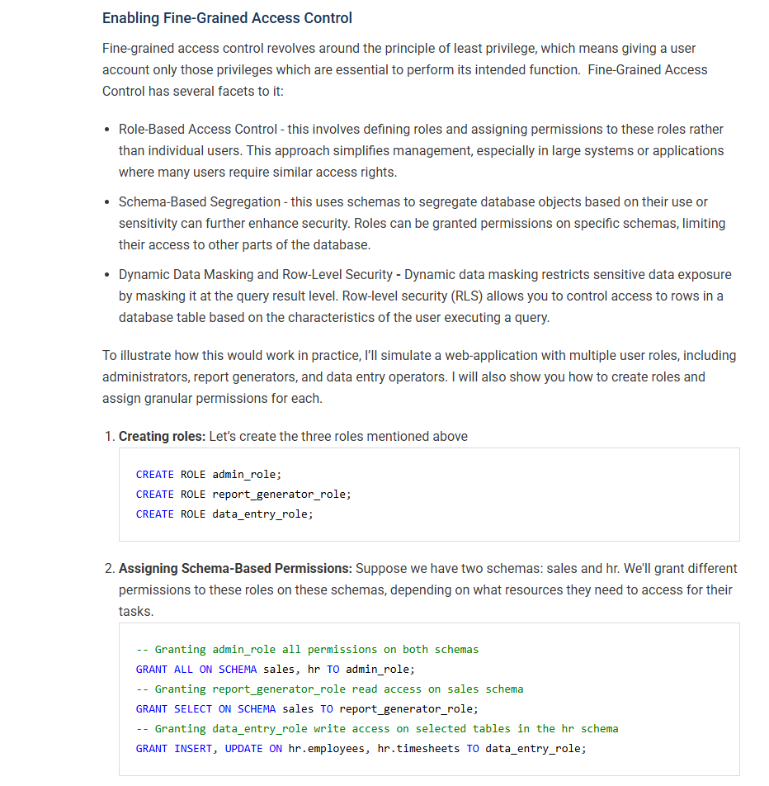

7. Tools & Technologies
- Database Platform: Microsoft SQL Server
- Development Tools: SQL Server Management Studio (SSMS)
- Interface Tool: Retool. Custom Software for developers for connecting to databases
Build a SQL Server GUI | Retool
l Retool | A better way to build custom software
- Environment: Windows Server platform (local or cloud-hosted)
- Validation Tools: Built-in SQL constraints and user-defined validation rules

8. Process / Workflow
How will the work get done?
- Requirements gathering with Team
- Schema design and scoping
- Development of tables, relationships, and constraints
- GUI interface creation Test data import/export
- User testing and feedback
- Security and Validation
- Documentation and training
- Final deployment
Folder/File Structure (if applicable):
- /docs: Documentation and schema designs
- /scripts: SQL scripts for schema and data import
- /data: Sample input/output files
- /benchtop: All records of benchtop testing
- /backups: Scheduled database dumps
- Sufficient internal IT support is available for handoff post-deployment.

9. Risks / Limitations
- Delays in infrastructure setup (if relying on external contractor).
- Inconsistent input data formats could cause import failures.
- GUI usability challenges for non-technical users.
- Risk of scope creep without clear feature boundaries.
- Security concerns if access controls are not rigorously enforced.

Tables:
Summary  Wafer Id  No. Built  No. Rework  No. Scrap  No. Accepted  Pt. Accepted  Use Allocation  Under Review | Inventory  Serial Number  Wafer Id  Board Status  Firmware  Location | Card Use  Date  Serial Number  Wafer Id  Board Status  Use Allocation  Location

Card Summary  Serial Number  Times Use  Date Log  Use Allocation | Tracking  Date  Shipment Number  In Transit Inventory  Mode  Shipping Company  Expected Delivery Date  Delivery Date  Shipped From  Shipped To  Shipment Successful? | Device Rework  S/N  Wafer Id  Date Sent for Rework  Sensors to be Reworked  Firmware Reloaded  Date of Rework  Rework Results  Rework Failure Reason  Date Returned to Vocxi  Date of Vacbake  eTest  Scrap? Failure Mode  Returned for 2nd Rework

Device Rebuild  S/N  Wafer Id  Returned from Clinic  Disassemble from Housing  Visual Inspection  Ethanol Rinse  Rebuild Vacbake  Rebuild eTest  Assembled into housing  Sealed in foil pouch  Send to Field | Manufacturing  Func Lot History Records  Graphenea  Solvent Solutions  Wafer Functionalization's | Benchtop Testing  Date  Sort By  Analytical Validity Testing

Purchase orders  Sort by Date/Type | Clinical Study  Protocols  Data/Patient Folders  Patient Survey’s  RedCap Data | Documentation  FDA  Literature  Previous Clinical Studies

Technical Reports

